4GQ25.JPG
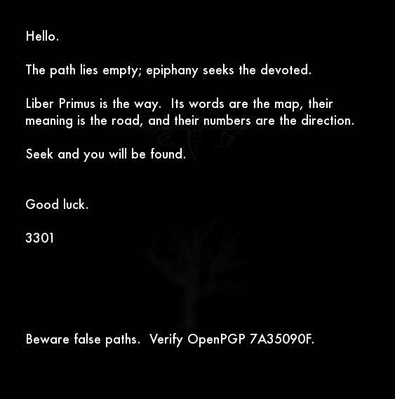4gq25.jpg
OutGuess :::::: Processed Image
Summary:
On January 5th, 2016, Cicada’s official Twitter account tweeted a link to infotomb.com/4gq25.jpg . This link no longer works, as Infotomb is now non-functional. This link led to 4gq25.jpg
The apparent purpose of this image seems to be to confirm the status of Liber Primus as Cicada’s active challenge — as well as to warn against pursuing the puzzles of imitators.
Size:
563 x 569 (both prime) , 25.7KB (257 is prime)
Notes:
+ Two figures can be seen faintly in the background of 4gq25.jpg : a cicada and an oak tree — both also found in Liber Primus.
————
* Given 4gq25.jpg‘s use of the phrase ‘epiphany seeks the devoted’, and the image’s release date of January 5th, it should be noted that January 6th is the traditional date of the Christian holiday ‘Epiphany‘, which celebrates the Theophany of Christ.
** The word ‘Epiphany‘ has been used before. In zN4h51m.jpg, the opening image of the 2014 round released on January 6th, 2014, the phrase ‘Epiphany is upon you.‘ was used.
*** Cicada’s three annual challenges (2012, 2013, 2014) were released, respectively, on:
January 4th, January 5th, and January 6th.

4GQ25.JPG OUTGUESS

-----BEGIN PGP SIGNED MESSAGE-----
Hash: SHA1

Hello.

The path lies empty; epiphany seeks the devoted.

Liber Primus is the way. Its words are the map, their
meaning is the road, and their numbers are the direction.

Seek and you will be found.

Good luck.

3301

Beware false paths. Verify OpenPGP 7A35090F.

-----BEGIN PGP SIGNATURE-----
Version: GnuPG v1

iQIcBAEBAgAGBQJWhcHDAAoJEBgfAeV6NQkP8GUP/iDXI/9lqvu/HTCujpPcIgYJ
H0Z8FdHDjz86A9yeyXYEUwPu1cLjSNUyGLBlu5dXuGpakuVeHtHnocuwrY24E2o4
Bnaqd1U8hUVU4Y68Va+jRIKS2NrPwg+HFFHr44DHKLHBM4CRqhLBFin36CeUIWmi
jykPMWwrLgxLy8FNXHvN/Fxqt0dbZ6/g1pxM2XOVEvy8bW/Xj7rj3VJGFOL7YVmM
Lae2PuCbmLZD/gaIhbGcPG7NEyUpFBbKEZ6Ul5i5LMeaRgS6KJHwLykeYdGWn65v
j8uY8+5zLBYus/OdbAZiiY6FnOgU/ESRQChQZILxiUIVT/OtFjz5IHrcVg3otoHl
tVfnSvqEk/AJ+w/MscTIBdxLPuvHmYD1B1XK/uZCRP/Dby6x8NFAR/zKAsqzkTY7
E4m34JzcPdsTnla0zmnz/O90jijfH+QAogyZSuEpdJIJlyFSzvDwhDme55gIAC0x
E1W7mxiOdss+Ebbmyyv4ul+l0UCB3qzfLw2Vijxmw/nWoDRqKk6kJf9vWL05BRu9
RoAap3rh0AC7SCV3fHjQj5VOUEJzHoz4YzrK15sa7SOZfeiP6XpfdzZfesiAWI8x
MUiyTFIqCeWZWJoSIe/1yFtumTkXO8/Dn0SCx9D4R6DVSiM9PRSdYgzT/+oRlIEl
Y8f7hrgdyn31uqGUgV4q
=sKXT
-----END PGP SIGNATURE-----

4GQ25.JPG PROCESSED
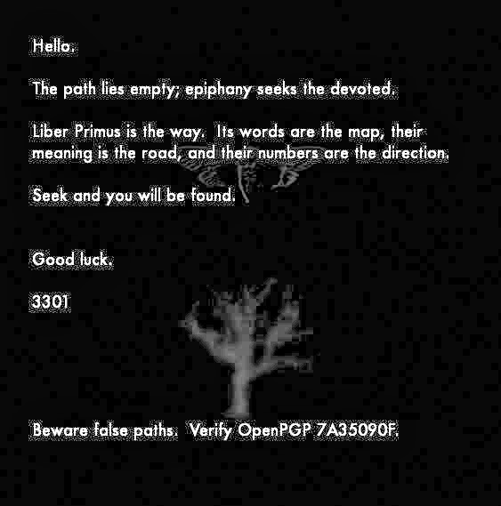4gq25.jpg processed
This is just a version of 4gq25.jpg whose contrast and brightness levels have been adjusted so that the cicada and oak tree figures are more visible. The blocks throughout the background are image compression artifacts, not QR code.

